Disaster Management System
By Remotz Systems

Deliverable-2

Project Team

Muhammad Moiz Ansari 23i-0523
Zohaib Umer 23i-0528
Rehan Tajik 23i-0730
Muhammad Tayyab 23i-0738

Semester 6

Supervised by
Ms. Rabail Zahid



Department of Computer Science National University of Computer and Emerging Sciences Islamabad, Pakistan
March 25th, 2026

PART B — Development Methodology (Scrum) — Sprint 2

1. Sprint Backlog for Sprint 2
1.1 Module Name
User Authentication & Disaster Reporting

1.2 User Stories
User Story 11:
Story ID: US-11 | Story Title: Manage Resources
User Story |  | Importance:
As an Admin, I want to manage resources so that I can efficiently allocate, update, and track resources for disaster response operations. |  | High
 |  | Estimate:
 |  | 3 day
Acceptance Criteria |  | Type:
- System provides options to Add, Edit, Delete, and Allocate resources.  - System displays available resources with details (type, quantity, status).  - System validates all inputs before saving changes.  - If invalid data is entered, the system shows an error message.  - System updates the resource database after confirmation.  - System logs all resource management actions for auditing. |  | ☐ Search  ☐ Workflow  ■ Manage Data  ☐ Payment  ☐ Report / View

User Story 12:
Story ID: US-12 | Story Title: Add Resource
User Story |  | Importance:
As an Admin, I want to add new resources so that they can be available for allocation during disaster situations. |  | High
 |  | Estimate:
 |  | 2 day
Acceptance Criteria |  | Type:
- System provides a form to enter resource details (type, quantity, description).  - System validates required fields.  - If invalid or incomplete data is entered, system shows an error message.  - Upon confirmation, the system stores the new resource in the database.  - System confirms successful addition of the resource.  - System logs the addition action. |  | ☐ Search  ☐ Workflow  ■ Manage Data  ☐ Payment  ☐ Report / View

User Story 13:
Story ID: US-13 | Story Title: Edit Resource
User Story |  | Importance:
As an Admin, I want to edit existing resources so that I can update their quantity, status, or details as needed |  | Medium
 |  | Estimate:
 |  | 3 day
Acceptance Criteria |  | Type:
- System allows admin to select a resource to edit.  - System displays current resource details.  - Admin can modify resource information.  - System validates updated data.  - If invalid data is entered, system shows an error message.  - Upon confirmation, system updates the resource in the database.  - System logs the update action with timestamp. |  | ☐ Search  ☐ Workflow  ■ Manage Data  ☐ Payment  ☐ Report / View

User Story 14:
Story ID: US-14 | Story Title: Delete Resource
User Story |  | Importance:
As an Admin, I want to delete resources so that outdated or unnecessary resources can be removed from the system. |  | Medium
 |  | Estimate:
 |  | 1 day
Acceptance Criteria |  | Type:
- System allows admin to select a resource for deletion.  - System asks for confirmation before deleting.  - If confirmed, system removes the resource from the database.  - If deletion fails, system shows an error message.  - System logs the deletion action for auditing purpose |  | ☐ Search  ☐ Workflow  ■ Manage Data  ☐ Payment  ☐ Report / View

User Story 15:
Story ID: US-15 | Story Title: Allocate Resource to NGO/Rescue Team
User Story |  | Importance:
As an Admin, I want to allocate resources to an NGO or Rescue Team so that they have the necessary supplies to execute their disaster response operations. |  | High
 |  | Estimate:
 |  | 2 days
Acceptance Criteria |  | Type:
- The system allows the Admin to select a specific NGO or Rescue Team from an active list.  - The system provides an interface to select the resource type and quantity to be assigned.  - The system verifies availability and deducts allocated items from the central inventory.  - The system displays a success message confirming the allocation and notifies the team. |  | ☐ Search  ☐ Workflow  ■ Manage Data  ☐ Payment  ☐Report / View

User Story 16:
Story ID: US-16 | Story Title: View Allocated Resources
User Story |  | Importance:
As an NGO / Rescue Team member, I want to view the resources allocated to my team so that I know what equipment and supplies are available for our current mission. |  | High
 |  | Estimate:
 |  | 1 day
Acceptance Criteria |  | Type:
- System retrieves and displays a list of resources currently allocated to the logged-in user's team.  - The user can view specific details such as resource type, quantity, and date of allocation.  - If no resources are currently assigned, the system displays "No allocated resources found." |  | ☐ Search  ☐ Workflow  ☐ Manage Data  ☐ Payment  ■ Report / View

User Story 17:
Story ID: US-17 | Story Title: Request Additional Resources
User Story |  | Importance:
As an NGO / Rescue Team member, I want to request additional resources so that we can swiftly replenish our supplies and avoid shortages during a disaster response. |  | Medium
 |  | Estimate:
 |  | 2 days
Acceptance Criteria |  | Type:
- User can access a request form and select the required resource type and desired quantity.  - User must provide a mandatory brief justification or reason for the request.  - Upon submission, the system automatically routes the request to an Admin for review.  - System displays "Request submitted successfully" and updates the request status to 'Pending'. |  | ☐ Search  ■ Workflow  ☐ Manage Data  ☐ Payment  ☐ Report / View

User Story 18:
Story ID: US-18 | Story Title: Call For Emergency
User Story |  | Importance:
As a citizen, I want to trigger an emergency call so that I can receive immediate, location-based assistance during a life-threatening disaster. |  | Critical
 |  | Estimate:
 |  | 3 days
Acceptance Criteria |  | Type:
- Citizen can activate the emergency alert via a prominent, single-action SOS button.  - System automatically captures the user's current GPS location and attaches it to the alert.  - System immediately routes the distress signal to the nearest available Rescue Teams and Admin.  - System displays an immediate confirmation message to the citizen indicating help is dispatched. |  | ☐ Search  ■ Workflow  ☐ Manage Data  ☐ Payment  ☐ Report / View

1.3 Structured Specifications
Specification 5 - US-11: Manage Resources
Field | Details
Use Case Name | Manage Resources
Actor(s) | Admin
Inputs | - Admin chooses an option to add, remove, update, or allocate resources.  - Enters required details in the form.  - Confirms allocation.
Outputs | - System shows management options and input forms.  - Displays validation/error messages.  - Shows update status.
Processing | - System validates the entered information.  - Assigns resources to the Rescue team or NGO.  - Updates the database.
Preconditions | - Admin must be logged in to an account.  - Resources must be available.  - Rescue team or NGO must be registered.
Postconditions | - The resource database is updated.  - Allocated resources are reflected in team/NGO accounts.  - Logs of resource actions are stored.
Exceptions | - Invalid data entered.  - Insufficient resources.  - Database error.

Specification 6 - US-16: View Allocated Resources
Field | Details
Use Case Name | View Allocated Resources
Actor(s) | NGO
Inputs | NGO selects the option to view allocated resources.
Outputs | System shows a database of allocated resources.
Processing | System retrieves and displays the allocated resource records.
Preconditions | - NGO must be registered and authorized  - Resources must be allocated by the admin and available in the database.
Postconditions | NGO can plan and assign resources to its teams (Medical, transport, etc.).
Exceptions | Database Disconnected (System shows error message "Can't load database" and attempts to load data again).

Specification 7 - US-17: Request Additional Resources
Field | Details
Use Case Name | Request Additional Resources
Actor(s) | NGO
Inputs | NGO requests more resources if needed.
Outputs | System responds with a resource update.
Processing | System processes the request and updates resources (if the admin approves).
Preconditions | NGO must be registered and authorized.
Postconditions | Resource allocation is updated for the NGO to distribute.
Exceptions | Response Error (System sends response again).

Specification 8 - US-18: Call for emergency
Field | Details
Use Case Name | Call for Emergency
Actor(s) | Citizen
Inputs | - Citizen selects "Call for Emergency”  - Provides necessary information (location and emergency type)  - Sends confirmation.
Outputs | - System alerts the nearest rescue team.  - Notifies the admin  - Updates the citizen about rescue team progress.
Processing | - System validates information.  - Routes the alert to the closest available rescue team.  - Notifies the admin.  - Updates progress upon team acknowledgment.
Preconditions | - User must have access to the system application.  - System is connected to emergency contact networks and rescue databases.
Postconditions | - Emergency alert is sent  - System records the emergency call in the database  - Admin is notified for follow-up actions.
Exceptions | - Citizen fails to provide location.  - Invalid data entered.  - Notification failure.  - Rescue team unavailable.

2. Scrum Board (Trello Snapshots)
2.1 Snapshot 1 — Initial Backlog Upload
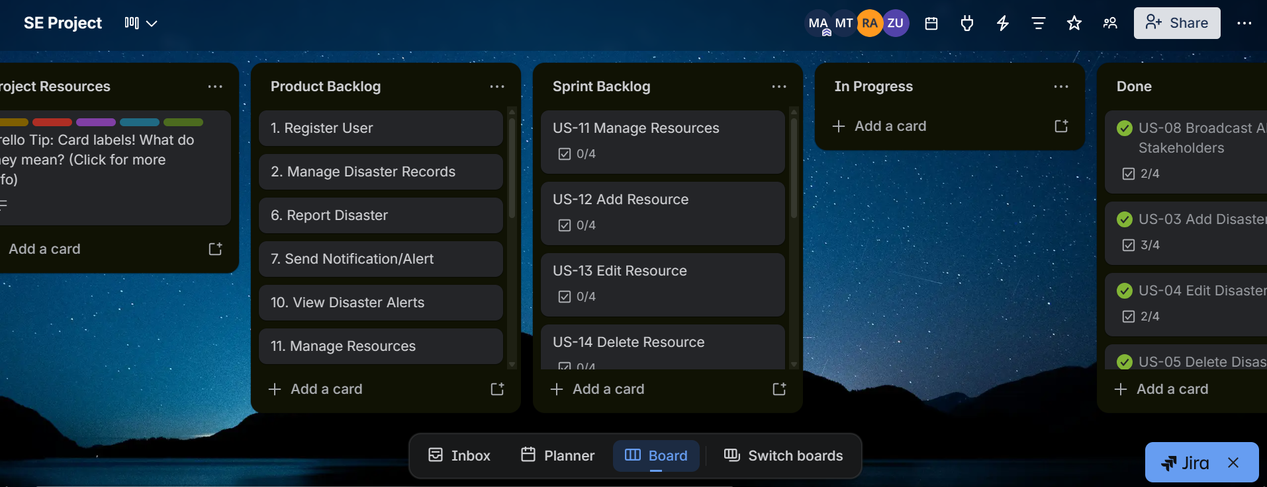

2.2 Snapshot 2 — Mid-Sprint Progress
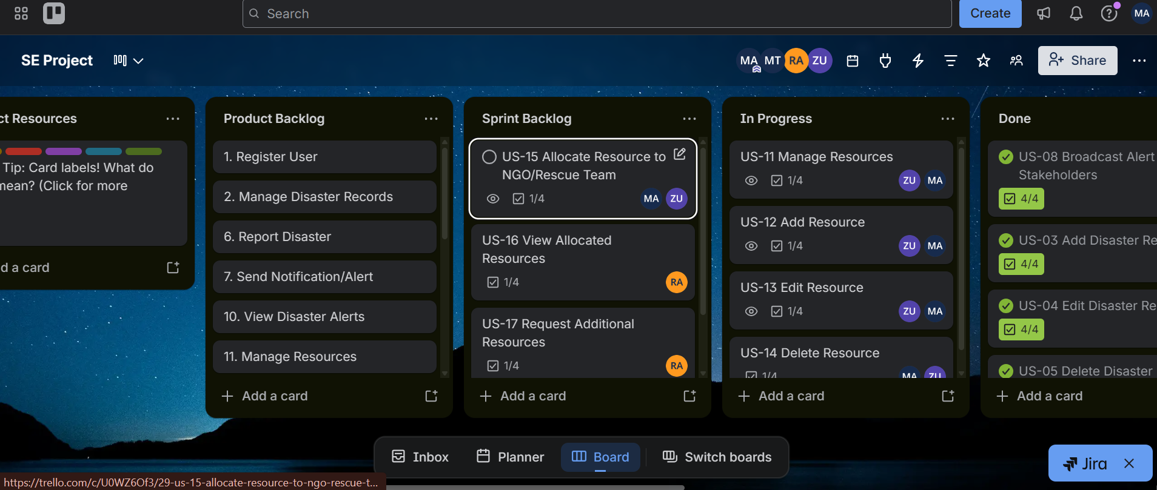

2.3 Snapshot 3 — End of Sprint
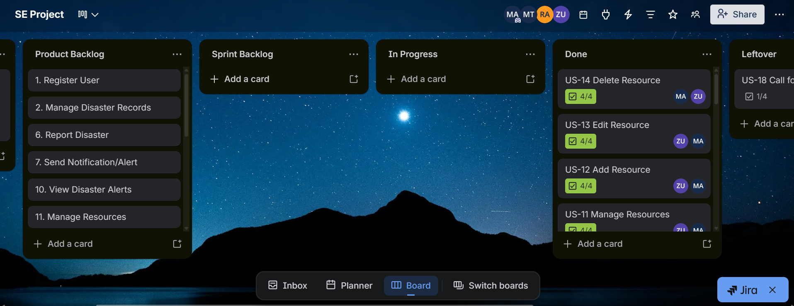

2.4 Product Burn-Down Chart — Sprint 1

